

DLD Lab-03

Special Purpose Gates



February 6, 2023

NATIONAL UNIVERSTIY OF COMPUTER AND EMERGING SCIENCES, FAST- Peshawar Campus

Department Of Computer Science

Instructor: Mazhar Iqbal

EL227 – Digital Logic Design-Lab

SEMESTER SPRING 2021

Contents

1. Objectives: 2

2. Outcomes: 2

3. Equipment Required: 2

4. Implementation of X-OR gate using X-OR IC: 2

5. Implementation of X-NOR gate using X-NOR IC: 3

6. Test the functionality of 2-Input XOR Gate. 5

7. Test the functionality of 2-Input XNOR Gate using XOR and NOT gates. 5

# Objectives:

To become familiar with Boolean algebra and using a Boolean expression to implement X-OR and X-NOR gates using basic AND, OR and NOT gates.

# Outcomes:

Students should be able to:  
 Implement XOR gates and XNOR gates using basic gates and debug a circuit.

# Equipment Required:

* DEV-2765E Trainer Board/ Multisim 14.2 /Logic.ly
* 7404 hex NOT (Inverter) gate IC
* 7408 quad 2-input AND gate IC
* 7432 quad 2-input OR gate IC
* 7486 quad 2-input XOR gate IC
* 4077 quad 2-input XNOR gate IC

# Implementation of X-OR gate using X-OR IC:





***Truth Table***

|  |  |  |
| --- | --- | --- |
| Input | | Output |
| X | Y | Z |
| 0 | 0 |  |
| 0 | 1 |  |
| 1 | 0 |  |
| 1 | 1 |  |

Boolean Representation for X-OR Gate is:

** A B = A.B + A.B**

**Gate Diagram of the above Boolean function:**

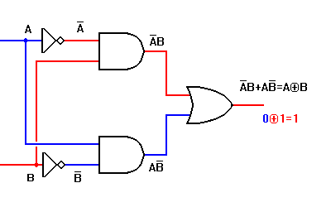

**Zout**

***Truth Table***

|  |  |  |  |  |  |  |
| --- | --- | --- | --- | --- | --- | --- |
| **A** | **B** | **A** | **B** | **A.B** | **A.B** | **A.B + A.B = Zout** |
| 0 | 0 |  |  |  |  |  |
| 0 | 1 |  |  |  |  |  |
| 1 | 0 |  |  |  |  |  |
| 1 | 1 |  |  |  |  |  |

# Implementation of X-NOR gate using X-NOR IC:





***Truth Table***

|  |  |  |
| --- | --- | --- |
| Input | | Output |
| X | Y | Z |
| 0 | 0 |  |
| 0 | 1 |  |
| 1 | 0 |  |
| 1 | 1 |  |

Boolean Representation for X-NOR Gate is:

** A B = A.B + A.B**

**Gate Diagram of the above Boolean function:**

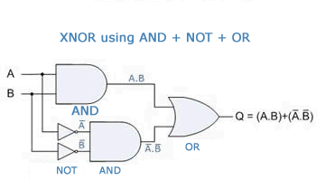

***Truth Table***

|  |  |  |  |  |  |  |
| --- | --- | --- | --- | --- | --- | --- |
| **A** | **B** | **A** | **B** | **A.B** | **A.B** | **A.B + A.B = Q** |
| 0 | 0 |  |  |  |  |  |
| 0 | 1 |  |  |  |  |  |
| 1 | 0 |  |  |  |  |  |
| 1 | 1 |  |  |  |  |  |

***Procedure***

1. Connect the trainer board with the power supply
2. Mount the corresponding gate IC’s on the board.
3. Connect pin 14 to +5 V and pin 7 to GND of all ICs.
4. Wire the circuit according to the diagram given above.
5. Apply all the combinations of inputs and observe the output on the LED to verify the truth table of the circuit. Also debug the circuit at intermediate points.

# Test the functionality of 2-Input XOR Gate.

# Test the functionality of 2-Input XNOR Gate using XOR and NOT gates.